**Tutorial 3**

1. **An Inventory Management System for an organization. – Waterfall model(for systems which have complete idea how to do it)**
2. **A total health care management system linking all the hospitals, laboratories, and doctors in Sri Lanka. Then patients can find all the health care services in one place. Ministry requires an initial version of the system to be launched at a particular day. The system can be completed gradually linking all hospitals, health care services, laboratories, and doctors. – Incremental model(for system which needed quick output of product with basic functionalities which will be updated in future)**
3. **Your company has an idea to develop a Household Robot. This robot will assist in almost all the housekeeping activities such as cleaning, painting, washing clothes and cooking. Your team has experience in developing assistive robots prior to this. But this new robot will be a more sophisticated product. Initially, you must identify suitable business partners to sponsor / manufacture the robots for sale – Prototype( because has to identify suitable business partners to sponsor for the product prototype model will be much better because developers can show them and get their attention)**
4. **A multiple rocket launcher control system for U.S air force. (Unfortunately, your team has absolutely no experience of developing this type of software.) – Spiral model(this is a critical system with risk management so better option is spiral model)**
5. **A simple data processing project. – waterfall model(for simple project with complete knowledge of scope of the project )**
6. **A Web-site for an on-line store which has a long list of desired features it wants to add, and it wants a new release with new features to be done very frequently.” – Incremental model (for long projects, for products which needed to be delivered quicky to market with limited functions)**
7. **A Corona-detecting system is a technologically challenging system that has some innovative concepts. Also, client expects quick solution to prevailing condition of the current context. – Spiral model (because it is a safety critical system including need of quick product)**
8. **BMW Company intends to manufacture child safety unit in first time history. – Spiral model(because it is a safety critical system )**
9. **Sri Lanka needs an Election Management System in next two months. – Incremental model ( quick product is needed with rapid development)**

**Explore V model and compare it with waterfall model**

|  |  |
| --- | --- |
| **Waterfall model** | **V - Model** |
| **Low cost** | **High cost compared to waterfall model** |
| **Low in flexibility** | **Flexibility increased compared to waterfall** |
| **Steps move in a linear way** | **Steps don’t move in a linear way** |
| **Re usability is low in waterfall model** | **Can be re usable compared to waterfall model** |
| **Guarantee of success through waterfall model is low** | **Guarantee of success through waterfall model is high** |

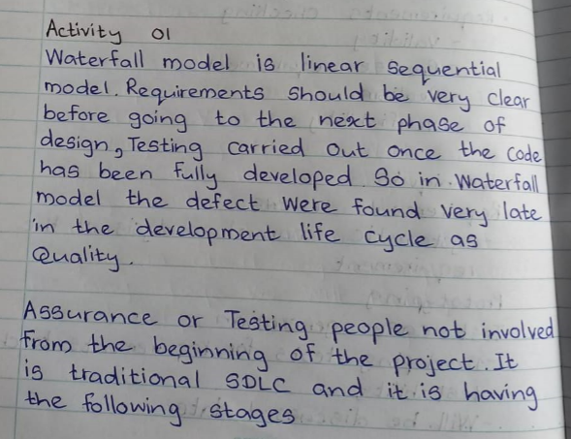

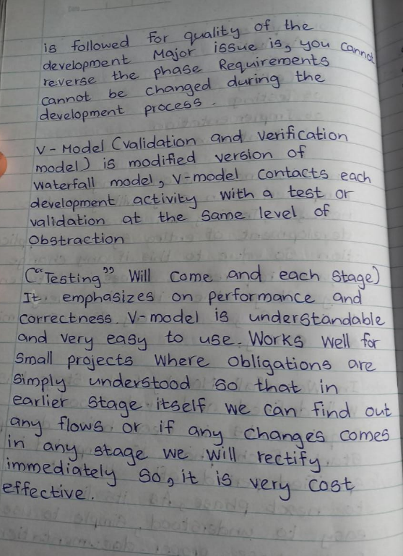

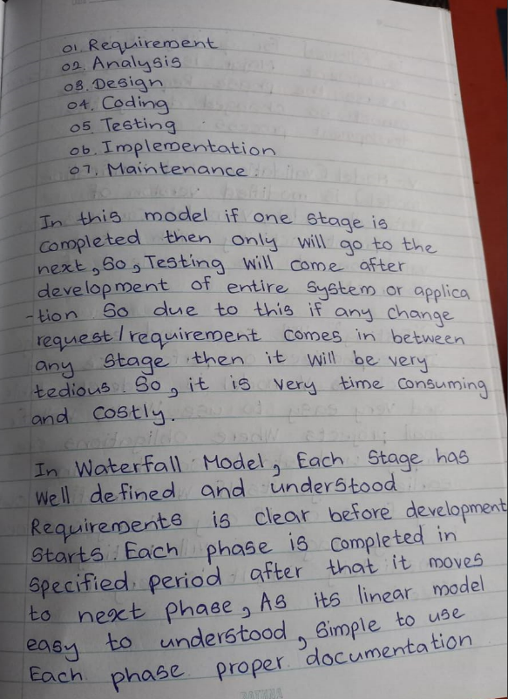

Activity 02

* What you should consider when selecting a good SDLC model
  + Requirements
  + Team experience
  + Time to complete the process
  + Budget
  + Risk tolerance

Activity 03

identify main features of Unified Process (UP) model and compare with Incremental model.

* Has incremental and iterative nature
* Tow dimensional
* Task is divided into increments.
* Within each increment the developers have to iterate until task is completed



